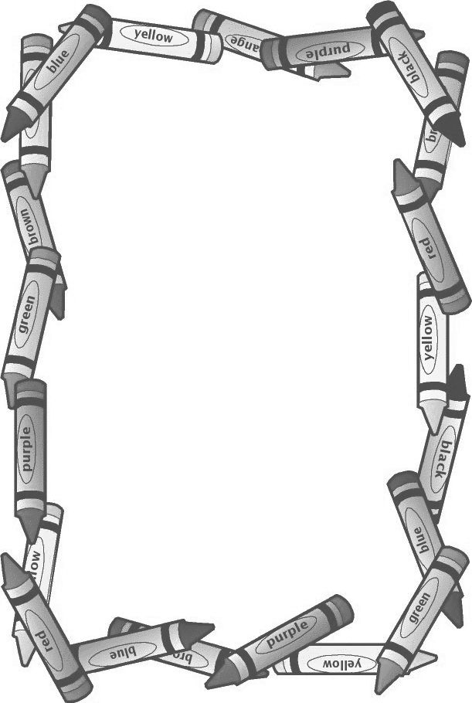

**Record your book titles online at**

<https://wandooreader.com/concordlibrary/101-picture-books-cfpl-loves>

**Color an owl together for every book read.**

**Congratulations, you read all 33 books!**

**Bring this sheet and come to the Library to collect your reward and next sheet!** Your name here:______________________________________________