Concord Free Public Library’s **101 Picture Books CFPL Loves program** is a fun, exciting, and free way to start your child on the right path! Any child ages birth to five years can participate.

**Just follow these steps**

* **Register:** Sign up online at <https://wandooreader.com/concordlibrary/101-picture-books-cfpl-loves>
* **View Book Titles:** Printed copies available at both libraries or print your own at our website on the “Kids > What to Read > 101 Picture Books” page.
* **Track Your Reading:** Color an owl in the brochure and record each book you read from this list **online**: <https://wandooreader.com/concordlibrary/101-picture-books-cfpl-loves>
* **33 Book Milestones:** Each time you read 33 books, bring the Owl coloring page to the library to receive a special reward!
* **You choose your own 101st title:** Please pick your own and log at the Wandoo link above.
* **101 Books:** You did it! Come celebrate at the library and receive a special surprise!
* **Keep on Reading:** Don’t stop at 101 books, keep on reading together; there’s more learning ahead!

**Special Storytimes**

We will be offering special Storytimes highlighting several of these books in September, January and May.

Come visit us during these Storytime months and collect a *special sticker*! See [www.concordlibrary.org](http://www.concordlibrary.org) to learn more.

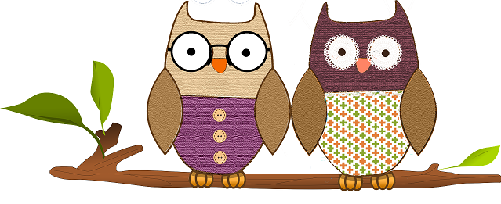

How Can You Get To 101 Books?!

Fall

***Read one bedtime story every night for 101 days.***

***Ten books a week for 10 weeks plus one day.***

***Twenty books a week for 5 weeks plus one day.***

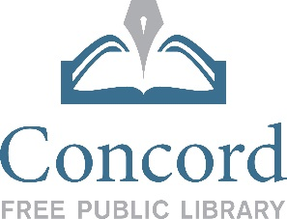

**www.concordlibrary.org**

**101 Picture Books Concord Free Public Library Loves**

***There is Always a Book for Every Child***

1. Each Peach, Pear, Plum by Janet Ahlberg
2. Where’s My Teddy? By Jez Alborough
3. Miss Nelson is Missing! By Harry Allard
4. Parts by Tedd Arnold
5. Extra Yarn By Mac Barnett
6. Have You Seen Elephant?by David Barrow
7. Rosie Revere, Engineer by Andrea Beaty
8. Journey by Aaron Becker
9. The Big Red Barn by Margaret Wise Brown
10. Marisol McDonald Doesn’t Match by Monica Brown
11. Mr. Tiger Goes Wild by Peter Brown
12. The Little House by Virginia Lee Burton
13. Stellaluna by Janell Cannon
14. From Head to Toe by Eric Carle
15. But, Excuse Me, That is My Book by Lauren Child
16. I Love You, Blue Kangaroo by Emma Chichester Clark
17. Miss Rumphius by Barbara Cooney
18. Pumpkin Soup by Helen Cooper
19. Yummy! Eight Favorite Fairy Tales by Lucy Cousins
20. Freight Train by Donald Crews
21. Click, Clack, Moo: Cows That Type by Dorothy Cronin
22. Nighttime Ninja by Barbara DaCosta
23. The Day the Crayons Quit by Drew Daywalt
24. On Market Street by Matt De La Pena
25. Jamberry by Bruce Degen
26. Oliver Button Is A Sissy by Tomie DePaola
27. The Gruffalo by Julia Donaldson
28. Go, Dog, Go by P.D. Eastman
29. Holey Moley by Lois Ehlert
30. Go Away, Big Green Monster! By Ed Emberley
31. Feast for 10 by Cathryn Falwell
32. When Green Becomes Tomatoes: Poems for All Seasons by Julie Fogliano
33. Ten Little Fingers and Ten Little Toes by Mem Fox
34. Corduroy by Don Freeman
35. Three Little Kittens Have Lost Their Mittens by Don Freeman
36. Millions of Cats by Wanda Gag
37. The Night World by Mordecai Gerstein
38. Orange Apple Pear Bear by Emily Gravett
39. Traction Man is Here! by Mini Grey
40. Shh! We Have a Plan by Chris Haughton
41. Kitten’s First Full Moon  by Kevin Henkes
42. In the Rain With Baby Duck by Amy Hest
43. Bread and Jam for Frances by Lillian Hoban
44. Dogger by Shirley Hughes
45. Peekaboo Morning by Rachel Isadora
46. A Greyhound A Groundhog by Emily Jenkins
47. Henry Hikes to Fitchburg by D.B. Johnson
48. The Snowy Day by Ezra Jack Keats
49. Arnie the Doughnut by Laurie Keller
50. Library Lion by Julian Knudsen
51. The Carrot Seed by Ruth Krauss
52. Dim Sum For Everyone by Grace Lin
53. Frederick by Leo Lionni
54. Pete the Cat: I Love My White Shoes by Eric Litwin
55. Frog and Toad Are Friends by Arnold Lobel
56. How I Became a Pirate by Melinda Long
57. What! Cried Granny: An Almost Bedtime Story by Kate Lum
58. Chicka Chicka Boom Boom by Bill Martin Jr.
59. The Very Hungry Caterpillar by Bill Martin Jr., Eric Carle
60. Guess How Much I Love You by Sam McBratney
61. Make Way For Ducklings by Robert McCloskey
62. I Stink by Kate and Jim McMullan
63. Lola at the Library; Lola Loves Stories by Anna McQuinn
64. A Kiss for Little Bear-Else Minarik
65. Jazz by Walter Dean Myers
66. The Peace Book; Be Who You Are by Todd Parr
67. Yummy Yucky by Leslie Patricelli
68. The Lion and the Mouse by Jerry Pinkney
69. The Piggy in the Puddle by Charlotte Pomerantz
70. Not A  Box by Antoinette Portis
71. A Ball For Daisy by Chris Raschka
72. Officer Buckle and Gloria by Peggy Rathmann
73. The Dot by Peter A. Reynolds
74. And Tango Makes Three by Justin Richardson and Peter Parnell
75. We’re Going On A Bear Hunt by Michael Rosen
76. All the World by Liz Gordon Scanlon
77. Where The Wild Things Are by Maurice Sendak
78. My Many Colored Days by Dr. Seuss
79. A Bad Case of Stripes by David Shannon
80. Sheep in The Jeep by Nancy A. Shaw
81. Caps for Sale by Espher Slobodkina
82. A Perfect Day by Lane Smith
83. Little Owl’s Night by Divya Srinivasan
84. A Sick Day for Amos McGee by Philip Stead
85. Brave Irene by William Steig
86. Mufaro’s Beautiful Daughters by John Steptoe
87. The Gardener by Sarah Stewart
88. The Monster at the End of This Book by Jon Stone
89. Little Quack by Lauren Thompson
90. Press Here by Herve Tullet
91. Down by the Station by Jennifer Riggs Vetter
92. Alexander and the Terrible, Horrible, No Good, Very Bad Day by Judith Viorst
93. Ira Sleeps Over by Bernard Waber
94. Owl Babies by Martin Waddell
95. Yoko by Rosemary Wells
96. Don’t Let The Pigeon Drive The Bus! By Mo Willems
97. More, More, More Said the Baby by Vera Williams
98. Bear Snores On by Karma Wilson
99. King Bidgood’s In The Bathtub by Don Wood
100. Dinosaur Series Title- Jane Yolen
101. **Your Choice! You pick the title and let us know what you read.**